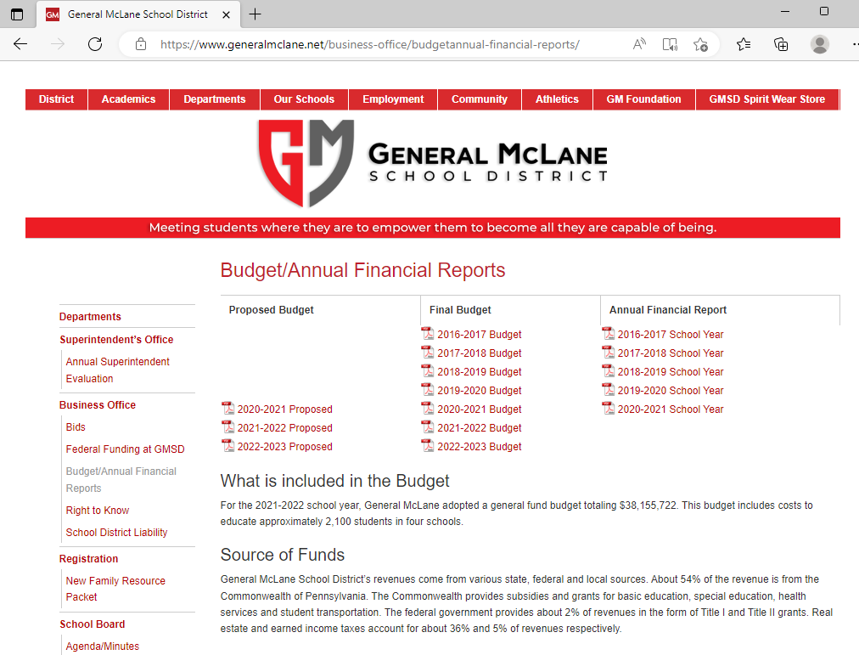

2016-17 Audit

2017-18 Audit

Etc.

Audited Financials