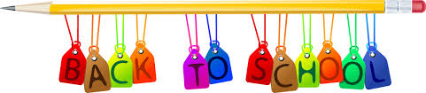**McKean Elementary Grade 1 Supply List**

Welcome to first grade! We are looking forward to a great year! We would like to ask you to supply your first grade student with a few things to start up our new year. We would like your child to bring these items on the first day of school. Please remove the erasers, Expo markers, scissors, highlighter and glue sticks from the packages before sending them to school.

1 - package of pink pet erasers (not pencil toppers)

2 boxes of **Crayola** Crayons (24 count)

1 - 12 count box of **Crayola** Classic colors Colored Pencils

6 - black chisel-tip dry-erase markers (**Expo** brand)

1 - eraser for dry-erase boards

1 - highlighter

1 - pair of **Fiskar** Scissors (blunt tip)

3 - boxes of tissues

24 - **Ticonderoga** plain yellow pencils

1 - plain pencil box

1 - box of gallon **Ziploc** zipper bags (boys only)

1 – box quart size **Ziploc** zipper bags (girls only)

1 - shirt to stay at school for Art (labeled with your child’s name)

1 - package of **Crayola** classic color markers

6 - Elmers glue sticks

A pair of headphones for iPads that can stay at school all year

~Optional~

Personal crayon/pencil sharpener

Baby wipes

Thank you for all of your support. We are looking forward to a great school year!

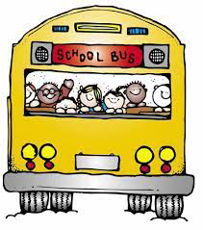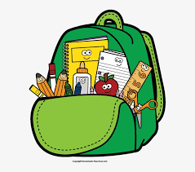The First Grade Teachers