Hello!! Welcome to Second Grade! The following is a list of supplies to prepare your child for a new school year. The General McLane School District would like to ask you to supply your student with a few things to start our new year. We would like your child to bring these items on the first day of school. Please purchase the brand recommended-the others break or do not work. Please only label when specified, the other items will become community items. Thank you for your support!

1 plain pencil box (labeled with his/her name)

1 box of 24 count Crayola crayons (labeled with his/her name)

1 box of 10 count Crayola markers (labeled with his/her name)

1 box of 12 count Crayola colored pencils (labeled with his/her name)

1 wide ruled spiral notebook (labeled with his/her name)

1 Elmers glue stick - Please get a LARGE glue stick and NOT RoseArt (labeled with his/her name)

1 eraser for dry-erase boards (labeled with his/her name)

2 highlighters-any color (labeled with his/her name)

1 pair of scissors (labeled with his/her name)

4- Two- pocket folders *1 red, 1 yellow, 1 green, and 1 blue* (labeled with his/her name)

24 Ticonderoga pencils (found at Staples and Target)

2 erasers for pencils

4 Black dry-erase markers (Expo brand-no whiteboard cleaner)

1 box of tissues

Headphones (No wireless please)

**Optional**:

Stylus pen (Recommended: 1.5mm fine point)

We are looking forward to a great year in Second Grade!

Sincerely,

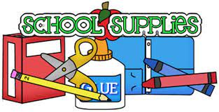Second Grade Teachers